**Pet Roll**

**Game Manual**

**A Game by Ben Willcox**

**How to play**

**Controls**

To move the character, use the WASD keys.

You can scroll in and out to control the zoom on the camera. This resets after each level.

R will reset the player to the start of the level.

P will return the player to the first level.

M will return the player to the main menu.

**Other**

There are currently 20+ coin objects in the game that will grant the player 1-2 coins, each.

**Tips & Tricks**

If you are getting stuck on the sideways ramps, try holding the W key along with the key that represents the same direction as the ramp. For example, for a ramp on the left, hold W and A to move quickly across the ramp while keeping the player more ‘attached’ to it.

If you miss a coin, there is nothing wrong with restarting at the beginning of the level and trying to grab it again.

**Game objects to be aware of**

**Image followed by description**

The “FINISH” rectangle will transport the player to the next scene/level.

Coins are collectible items that will increase the box which reads “$ ” by 2. Currently, coins are simply a score system that the player can use to figure out if they have collectedall the coins in the levels at the end.

Signs have text that might prove to be useful to the player if they take a quick glance. This is to ensure that every player at least knows what needs to be done to complete the level quickly or gain more coins.

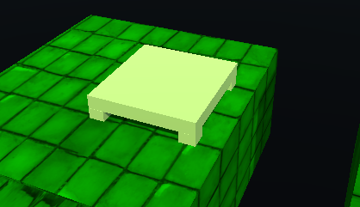

This is a bounce board. It absorbs the players fall damage when it is landed on, as opposed to the default ground which could damage or reset the player. Levels may be completed faster by using this object, even if that is not its original intended purpose.

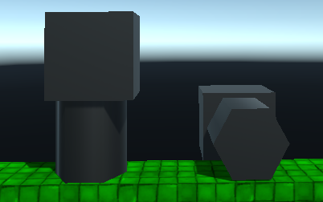

These piston-like objects push the player away from the square part of the object, depending on where the round part is. They may attempt to push the player off platforms, or they can be used as an elevator to move the player closer to the end of the level.

This purple object is a teleporter, and it will transport the player to the other teleporter object that is located elsewhere in the map. It is not introduced until the 10th level.